Northern Frontier Section of the Green Mountain Club
Summer Newsletter: June 2019
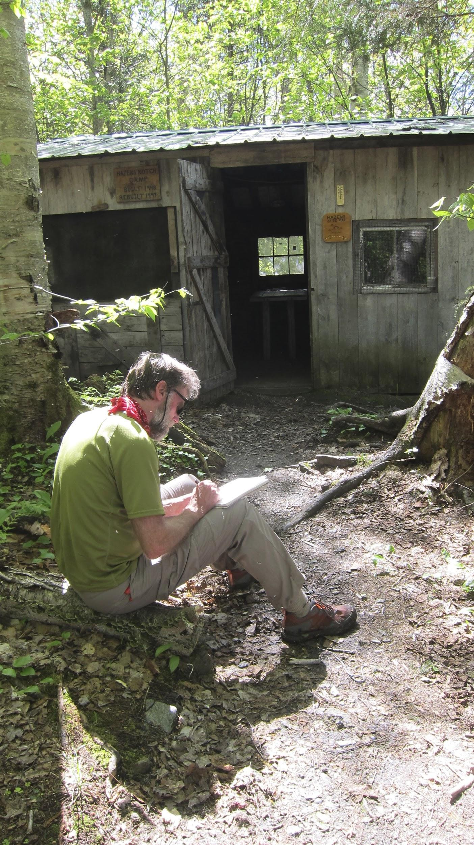
Greetings!

I took this photo of Walter Pomroy on our walk-through recently of Route 242 to Hazen’s Notch section of the Long Trail. We were at Hazen’s Notch Camp and very tired, having cut up blown down trees and clipped brush on most of that trail section. We were near the end of our walk and we still could appreciate Howard Van Benthuysen’s earlier brush clipping and journal entry at the camp. Howard has also made and installed a number of fine trail signs throughout the Northern Frontier Section. In addition, the GMC had installed plank walkways on a muddy trail section near the camp!

So far, most or all of the brush and blow-downs have been cleared from the Northern Frontier Section. Many thanks to all of our members who do the walk-throughs and maintenance (including Ferdinand Lauffer, who completed a very long day between Routes 105 and 242). We look forward to re-blazing parts of the trail between Route 242 and Tillotson Camp (see Trail Blazing dates). Also during this season, the GMC will replace the support under Laura Woodward and our section may help.

The northernmost section of the Long Trail (2.6 miles) from Route 105 to the Canadian border needs a new trail adopter (or adopters) to walk through and clear blow- downs and brush each spring. Ken and Sandra MacDonald have done the section for years and we thank them very much for their good work. They have finished their last walk-through this spring. If you are interested, please contact me to discuss it.

Those of you who perform volunteer work on the trail or shelters should either log in your hours on the GMC website or email me and I will send them in for you.

The outings and trail work we have scheduled are a good opportunity for a change of pace and a challenge. It looks like a good hiking season ahead and we hope for nice weather!
See you on the trail,

Ken Whitehead, President NFS

Upcoming Events
June 29 (Saturday) | Hike Rte 242 to Hazen’s Notch on the Long Trail. This is a moderate to strenuous hike. The distance is 6.8 miles over 4 peaks around 2900 feet in elevation. Contact Russ at 802-848-7303 or Russell.F.Ford@gmail.com
July 11 (Thursday) | Hike to Jay Camp from Rt. 242 and stop for lunch there. This is an easy/moderate hike. The distance is about 1 mile round trip.  Contact Jane at 802-827-3879 or janeallynwilliams@gmail.com
July 14 (Sunday) | Hike to Mt. Pisgah from the North Trail at Lake Willoughby. This is a moderate to strenuous hike and the distance is 4.6 miles round trip with an elevation change of 1530 ft. Contact Ken at 802-933-5352 or mrsswhitehead@gmail.com
Aug 10 (Saturday) | Hike to Jay Peak from Rt. 242. This is a moderate/difficult hike. This hike is in conjunction with the Jay Summer Fest. The distance is 3.5 miles and the vertical rise is 1680 feet. Contact Walter at 635-1770 or wjpomroy@gmail.com for time.
Aug. 24 (Saturday) | Bike ride from Jay Pass to S. Richford Rd to Rt 242 to Jay Country Store and back to Jay Pass. This is a strenuous trip and the distance is 37 miles. Contact Ferdinand at 802-933-4252 or flauffer@gmail.com
Sept. 14 (Saturday) | Hike Belvidere Mt. Loop. Bring a lunch. This is a moderate to strenuous hike and the distance is 8 miles. The elevation change is 1980 ft. Contact Ferdinand at 802-933-4252 or flauffer@gmail.com
Sept 23 (Monday) | Bike ride on the Lamoille Rail Trail from Jeffersonville to Johnson. This is an easy 9 miles. Contact Jane at 802-827-3879 or janeallynwilliams@gmail.com
Oct 5 (Saturday) | Paddle Green River Reservoir in Morrisville. This is flat water. Contact Ferdinand at 802-933-4252 or flauffer@gmail.com

Trail Blazing Dates: Contact Ken at 802-933-5352 or mrsswhitehead@gmail.com
July 17 (Wednesday): A meal will be provided at the Whitehead’s after blazing
Aug 13 (Tuesday)

Spring Meeting
We had a well-attended annual meeting of the Northern Frontier Section on May 19th at the Community Center in Montgomery. There was an abundance of good food and conversation. Thanks to everybody that brought a dish.

Treasurer’s Report - Walter
The Section is doing well financially, with a balance of $2,595. Of this, another $1,250 will put towards repairs at the Laura Woodward Shelter.

Trails and Shelters - Ferdinand
Shooting Star Shelter looks OK. The water pump sign needs to be replaced. Ferdinand will make a lamented set of instructions for the pump. The outhouse also needs to have more regular maintenance. The trail from Shooting Star to Rte. 105 needs to be re-blazed. Dates will be identified for re-blazing work groups.

Board of Directors Report – Russ
The Club is going to put a new foundation in at the Laura Woodward Shelter. Russ will send out dates when this construction is scheduled. The State Forestry Dept. is still working on a new management plan for Big Jay. It is not yet out for public comment. Russ submitted a grant application for a backcountry rescue sled, which was awarded. The sled will be kept at Jay Peak Ski Patrol. The Club also got a grant for a new privy at Journeys End, which should be going in this summer.

Other Business
- For the Mid-winter Taylor Series Ferdinand may give a presentation on his Great Divide bicycle ride this summer.
- Keegan’s crew will be assessing the trail conditions from Journeys End to Rte. 15 early this summer.
- The Club’s goal is too put a significant amount of capital funds into the trail over the next few years. This may include the purchase of a piece of land along the trail in Codding Hollow.
- There is also another section of trail in Montgomery that is still in private ownership. This may become available this summer and the state legislature may ut aside funding for it.
- The Club is in the process of making all of its publications available in electronic format.
- Bolton and Bryant Camps are now open and available.
- One of the Camps at Wheeler Pond is now being renovated.

Board of Directors Meeting – Annual GMC Meeting
There was a short Board of Directors meeting during the annual GMC meeting in Roxbury. The Board is actively looking to diversify its membership, especially with members that have special skills such as law and fund raising. Financially, the Club will end up with a $7,000 surplus for Fiscal Year 2019. Planning will begin this summer for design and location of Bromley Tower. The southern trail crew will be spending time this summer relocating trails around Stratton Pond. The northern trail crew will be working on the trail in Breadloaf Wilderness Area. The Club is trying to purchase two private parcels of land along the trail in Codding Hollow and one in Johnson. As of April 30th there were 9,069 voting members in the club, 53 active businesses and 8 corporate sponsors.

Officers
President Ken Whitehead (802 933-5352) mrsswhitehead@gmail.com
Vice President Jane Williams (802 827-3879) janeallynwilliams@gmail.com
Secretary Kip Potter (802 868-3125) pottersvt@comcast.net
Treasurer Walter Pomroy (802 635-1770) walter@pomroycpa.com
GMC Board Rep Russ Ford (802 848-7303) Russell.F.Ford@gmail.com
Trails Ferdinand Lauffer (802 933-4252) flauffer@gmail.com
Website Rolf Anderson (802 326-4799) rolfanderson@hazensnotch.org

